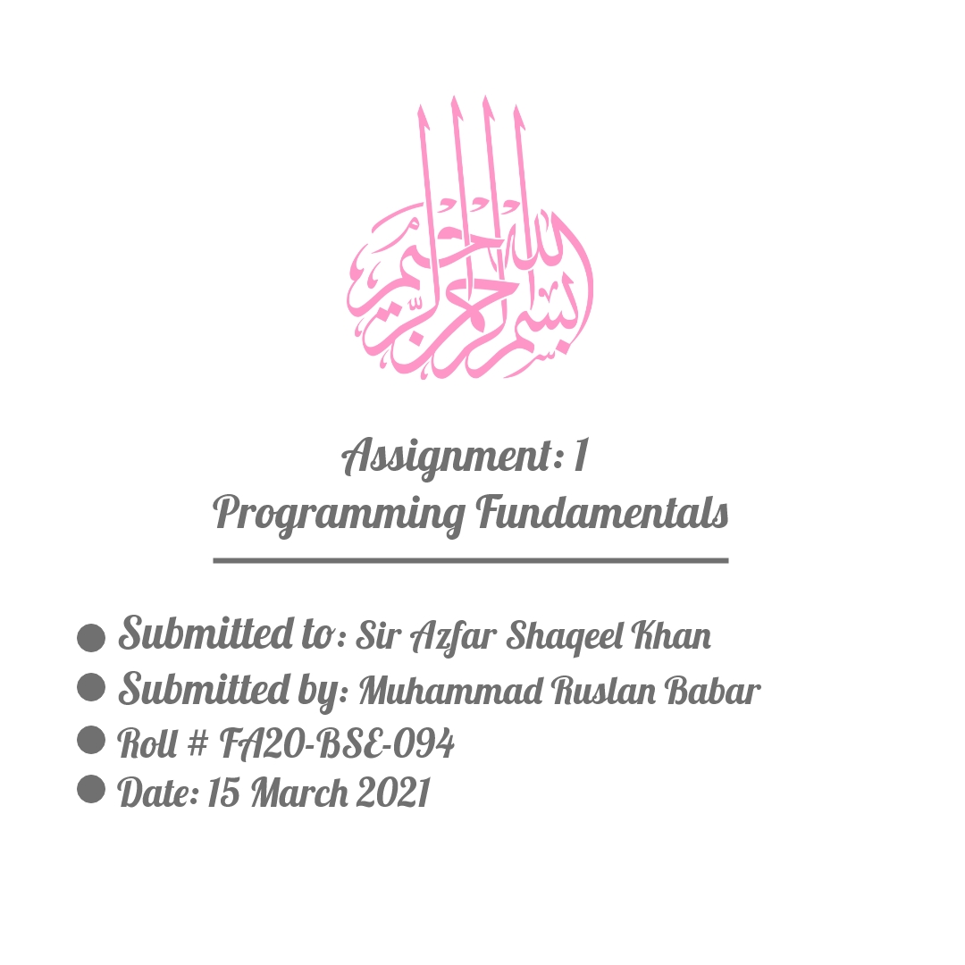

Chapter 12 – Lab Tasks



**Question1:**

*12.1 (NumberFormatException) Listing 7.9, Calculator.java, is a simple commandline

calculator. Note that the program terminates if any operand is nonnumeric.

Write a program with an exception handler that deals with nonnumeric operands;

Your program should display a message that informs the user of

the wrong operand type before exiting (see Figure 12.12).

**Source Code:**

import java.util.*;

public class Calculator_Question_One {

public static void main(String[] args) {

if(args.length != 3){

System.out.println("Please enter something to be processeded:");

System.exit(0);

}

double results = 0;

try {

switch (args[1].charAt(0)){

case '+': results = Double.parseDouble(args[0]) + Double.parseDouble(args[2]);break;

case '-': results = Double.parseDouble(args[0]) - Double.parseDouble(args[2]);break;

case '*': results = Double.parseDouble(args[0]) * Double.parseDouble(args[2]);break;

case '/': results = Double.parseDouble(args[0]) / Double.parseDouble(args[2]);break;

default: System.out.println("Wrong operator");

}

System.out.println(args[0]+" "+args[1]+" "+args[2]+" = "+results);

}

catch (NumberFormatException e){

System.out.println("Wrong input: "+e.getMessage());

System.exit(0);

}

catch (Exception x){

System.out.println("Wrong input: "+x.getMessage());

}

}

}

**All Possible Outputs:**

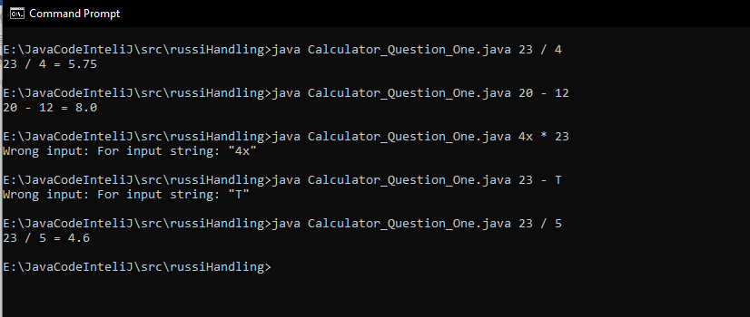

**Question 2:**

*12.2 (InputMismatchException) Write a program that prompts the user to read

two integers and displays their sum. Your program should prompt the user to

read the number again if the input is incorrect.

**Source Code**

package russiHandling;

import java.util.*;

public class InputMismatch_Question_Two {

public static void main(String[] args) {

//Scanner object for input

Scanner input = new Scanner(System.in);

//loop controller

boolean loop = true;

do{

//try block for some risky codes

try{

System.out.print("Enter two integers for summation: ");

int integerOne = input.nextInt();

int integerTwo = input.nextInt();

int sum = integerOne + integerTwo;

System.out.println("The sum is: "+sum);

loop = false;

//catch block that encountered the eroor in try block

}catch (InputMismatchException ex){

System.out.println("Your input is wrong\nTry proper inputs");

input.nextLine();

}

}while (loop);

}

}

**All possible Outputs:**

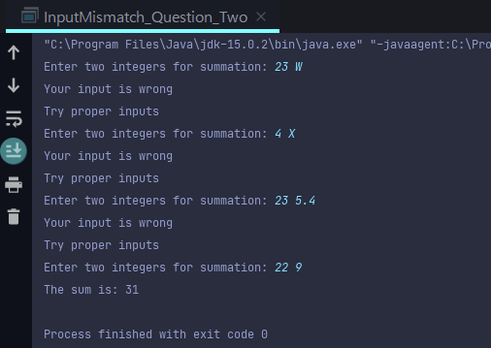

**Question 3:**

*12.3 (ArrayIndexOutOfBoundsException) Write a program that meets the following

requirements:

■ Creates an array with 100 randomly chosen integers.

■ Prompts the user to enter the index of the array, then displays the corresponding

element value. If the specified index is out of bounds, display the message Out of Bounds.

**Source Code:**

package russiHandling;

import java.util.*;

public class IndexOutOfBound_Question_Three {

public static void main(String[] args) {

Scanner input = new Scanner(System.in);

//declaring and initialization

int[] list = new int[100];

//Random number

for (int i = 0; i < list.length ; i++)

list[i] = randomGenerator();

//Loop controller

boolean loop = true;

do{

try{//try block for risky code

System.out.print("Choose an index:(1-100) ");

int index = input.nextInt();

System.out.printf("The number at index [%d] is [%d] ",index,list[index]);

loop = false;

}//catch block encounter statement

catch (IndexOutOfBoundsException ex){

System.out.println("Out of bound\nTry another index");

}

}while(loop);

}

//method for random number generator

public static int randomGenerator(){

return (int)(Math.random()*100);

}

}

**All Possible Outputs:**

